**Applications of ultrasonic sensors in real world**

**Ultrasonic sensor**

. An ultrasonic sensor is an electronic device that calculates distance by emitting sound waves and collecting their echoes.

A HC-SR04 ultrasonic sensor can measure objects from 2 to 400cm away, which makes it a versatile instrument for correctly measuring both short and long distances without making contact with the target object, which is critical in many applications such as obstacle avoidance systems in robotics or automation cars.

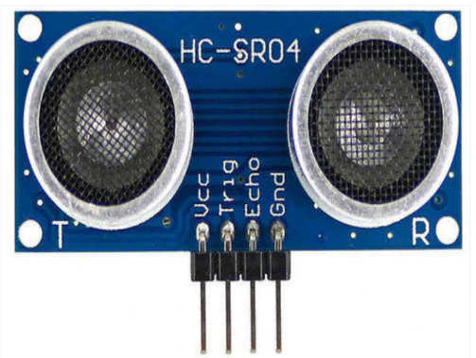

**Working Principle of Ultrasonic Sensor?**

An ultrasonic sensor is a type of electronic sensor that uses ultrasonic waves to determine

the distance between two objects and converts the reflected sound into electrical signals.

The working principle of an ultrasonic sensor is to measure distance using ultrasound, which travels faster than sound that is audible. This sensor consists of two major components a transmitter that generates sound waves via a piezoelectric crystal and a receiver that detects the reflected ultrasonic waves.

Distance of the object can calculated from the formula

Distance= Time taken * speed of sound / 2

**Applications of ultrasonic sensors**

1. Tank level monitoring:

Tank level monitoring is the process of measuring the level of liquid within a tank. This can be important in various applications such as water treatment, fuel management, and chemical storage.

Working Principle:

* Mount the Sensor: The ultrasonic sensor is typically mounted at the top of the tank, facing downwards.
* Transmit Ultrasonic Waves: The sensor transmits ultrasonic waves. If there is a liquid surface within its range, the waves will hit the surface and bounce back to the sensor.
* Receive and Process the Signal: The sensor receives the bounced back signal and calculates the time it took for the signal to return. This time is directly proportional to the distance from the sensor to the liquid surface.
* Calculate the Liquid Level: The liquid level in the tank is then calculated by subtracting the measured distance from the total height of the tank.
* Display or Transmit the Data: The liquid level data can be displayed on a local display or transmitted to a remote monitoring system via wired or wireless communication.

1. Drone Navigation or UAV Navigation:

Unmanned Aerial Vehicles (UAVs), also known as drones, can use ultrasonic sensors for navigation and obstacle avoidance. Here’s a brief explanation of how it works:

The ultrasonic sensor is typically mounted on the drone. The sensor transmits ultrasonic waves, and if there is an object within its range, the waves will hit the object and bounce back to the sensor. The sensor receives the bounced back signal and calculates the time it took for the signal to return. This time is directly proportional to the distance from the sensor to the object. By knowing the distance to nearby objects, the drone can navigate through complex environments and avoid obstacles.

**Key Features of Ultrasonic Sensors for Drones:**

* Measurement Range: Ultrasonic sensors used in drones typically have a measurement range of 2 cm to 4 m, with some high-end models capable of reaching up to 6 m or more.
* Accuracy: Most models used in drones have an accuracy of around 3 mm to 5 mm.
* Resolution: Drone-specific ultrasonic sensors often have a resolution of 1 mm or better.
* Beam Angle: Drones typically use sensors with a beam angle between 15° and 30°, allowing for a wider coverage area.
* Frequency: Ultrasonic sensors used in drones typically operate at a frequency of 40 kHz, which is above the human hearing range.
* Power Consumption: Drone ultrasonic sensors are designed to be energy-efficient, with low power consumption to minimize the impact on the drone’s battery life.

1. Motion sensors:

Ultrasonic sensors can be used as motion sensors due to their ability to detect the presence or movement of objects. Here’s a brief explanation of how it works:

The ultrasonic sensor emits ultrasonic waves, and if there is an object within its range, the waves will hit the object and bounce back to the sensor. The sensor receives the bounced back signal and calculates the time it took for the signal to return. This time is directly proportional to the distance from the sensor to the object. By knowing the distance to nearby objects, the sensor can detect motion.

1. **Distance measuring:**

Ultrasonic sensors measure distance by using the principle of echo and time of flight. Here’s a brief explanation of how it works:

Emit Ultrasonic Waves: The ultrasonic sensor emits high-frequency sound waves.

Detect Echo: If there is an object within its range, the waves will hit the object and bounce back to the sensor.

Measure Time: The sensor measures the time it took for the signal to return. This time is directly proportional to the distance from the sensor to the object1234.

Calculate Distance: The distance to the object is calculated using the formula1234:

Distance=2Time×Speed of Sound​

The division by 2 is because the sound wave has to travel to the object and back to the sensor, so the actual distance to the object is half of the total distance travelled**.**

1. **Tide gauge:**

An ultrasonic tide gauge is a device that uses ultrasonic waves to measure the height of the tide. Here’s a brief explanation of how it works:

The ultrasonic sensor is typically mounted at a fixed point above the water surface. The sensor emits ultrasonic waves, and if there is a water surface within its range, the waves will hit the surface and bounce back to the sensor. The sensor receives the bounced back signal and calculates the time it took for the signal to return. This time is directly proportional to the distance from the sensor to the water surface. By knowing the distance to the water surface, the sensor can calculate the tide level.

By

Priya Reka S